## Color themes and palettes

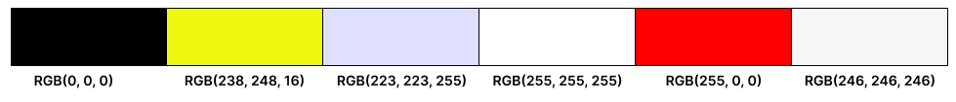

In total, I mainly choose six different colors for the website and application. Colors are black, yellow, blue, white, red and gray. The RGB value of each color can be found above.

About the most important color themes of the Zumba website and application, I choose to mainly use four colors which are black, yellow, blue and white. During the process of creating user interface design, black and yellow are used together to build the basic structure of the website that includes header and footer.

The navigation bar of the website is black. For businesses, the purpose of the navigation bar is to guide users to find the information they need. The presence of a black navigation bar is beneficial for recognizing different parts of website structure. Furthermore, the significant title information of the webpage can be locked in a black design box. Thus, users can quickly click on the different titles to jump to the corresponding page. Black is the darkest color, which emphasizes the importance of the navigation bar and reminds users not to ignore the information on the top.

The background color of the whole website is white. The reason why I chose this color is that white is very bright. In most cases, the font color is black. When customers open the website, the white background color can create the strong contrast with a black navigation bar and the font color which is black in the body of website. Thus, it can make customers be interested in reading and browsing the current page. Moreover, contrasting colors can help visually impaired people.

During the process of creating the administrator interface design, black, blue and white are used together to build client maintenance interface, class booking interface and attendance interface. The colors of header and body are black and blue separately. Moreover, the background color of the form is white. The form design is simple and clean. Hence, the whole interface can help the administrator to quickly enter registration information of club members, process class orders, and check attendance records. It also can help to streamline the registration and management processes. Administrators can use the system effectively.

The other two colors that are red, and gray can be used to increase the color richness of Zumba project design.

Font Family

In the header of the website and application, the name of the font is Inter, the font size is 36 and the font weight is 600. The font size in the header of the Zumba website and application should be apparent and larger than that in other area. There are two reasons are below.

1. Attention-Grabbing: A larger font size in the header is attention-grabbing and visually appealing. It helps draw the user's attention to the header information and creates a memorable impression.
2. Clarity and Readability: A larger font size, such as 36, can enhance the readability of the navigation bar in the header, especially when it is displayed on different devices with varying screen sizes, resolutions, and viewing distances.

About the other areas of the website and application, the name of the font is also Inter. The font size is 26 and the font weight is 400. Below are some reasons for this choice.

1. Balance and Hierarchy: The font size of 26 and the font weight of 400 strike a balance between readability and visual aesthetics. For example, in the text area, the font size, 26 is not so large and there are more words which can be accommodated in the text area.
2. Modern and Clean Appearance: "Inter" is a popular sans-serif font that is known for its modern and clean aesthetic. Using it with the font size of 26 and the weight of 400 creates a professional look when developing Zumba website and application.

The font name, Inter is same throughout the website and application. In addition, there is no italic font style used in both the website and application. Hence, the consistency in the design can be maintained and any visual inconsistencies that may arise from using different font styles can be avoided.

In summary, regarding Zumba project, the choice of font family aims to create a visually appealing, consistent and readable design throughout the website and application.

Wireframes

Wireframe - Home

Wireframe – Log in

Wireframe – My Timetable

Wireframe – Client maintenance

Wireframe – Class Booking

Wireframe - Attendance

Mock-ups

Mock-up - Home

Mock-up – Log in

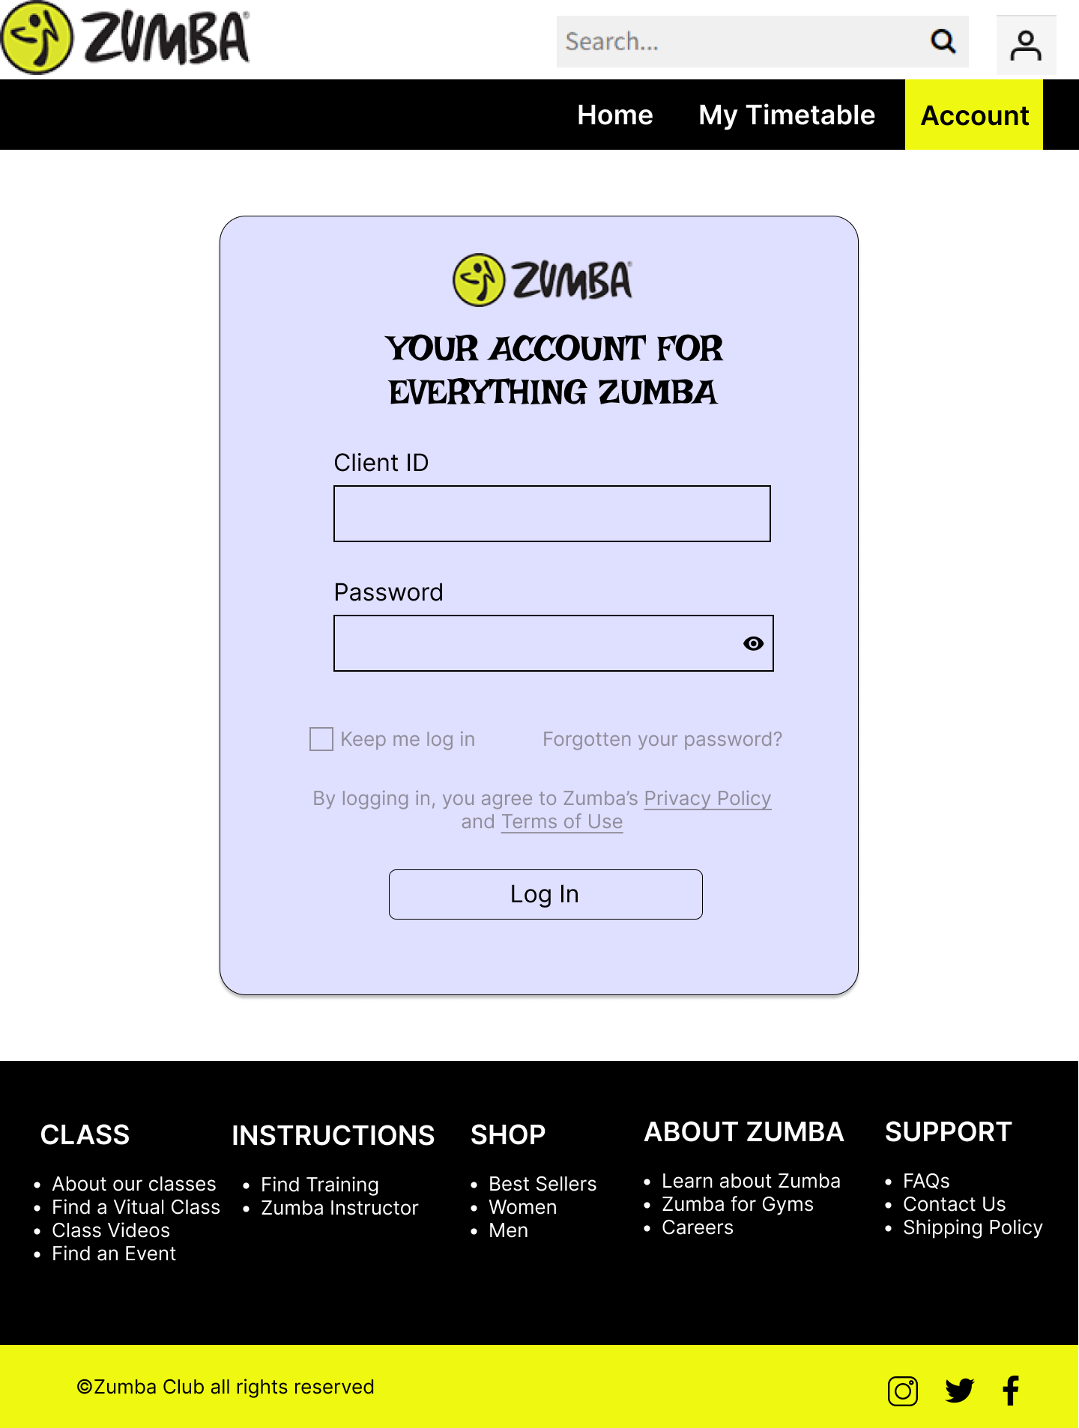

Mock-up – My Timetable

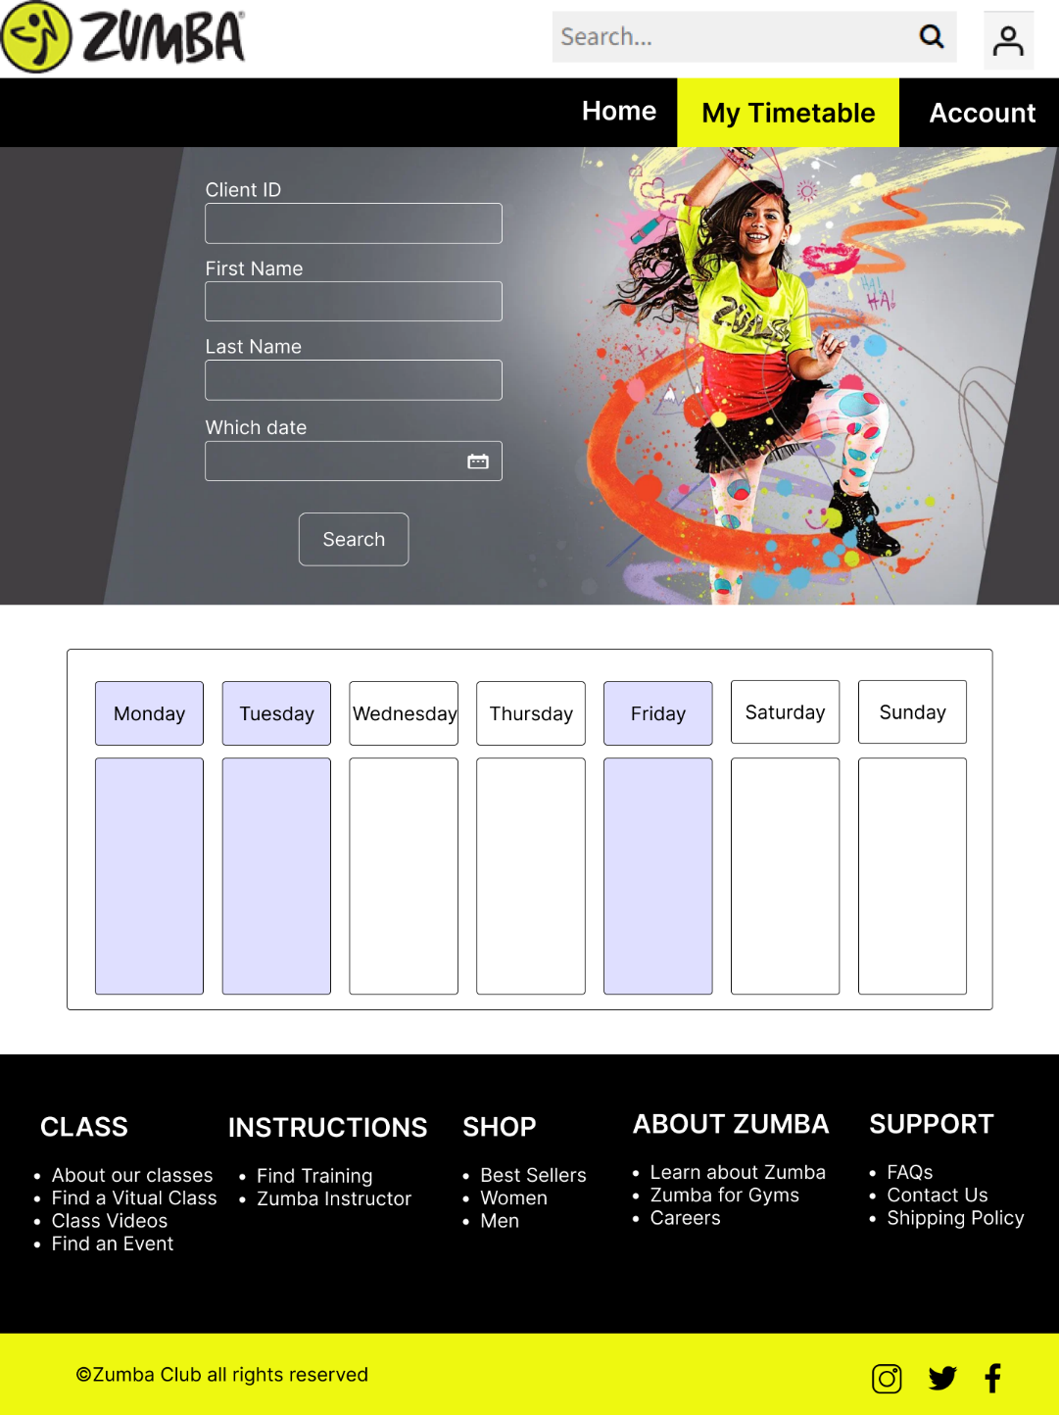

Mock-up – Client Maintenance

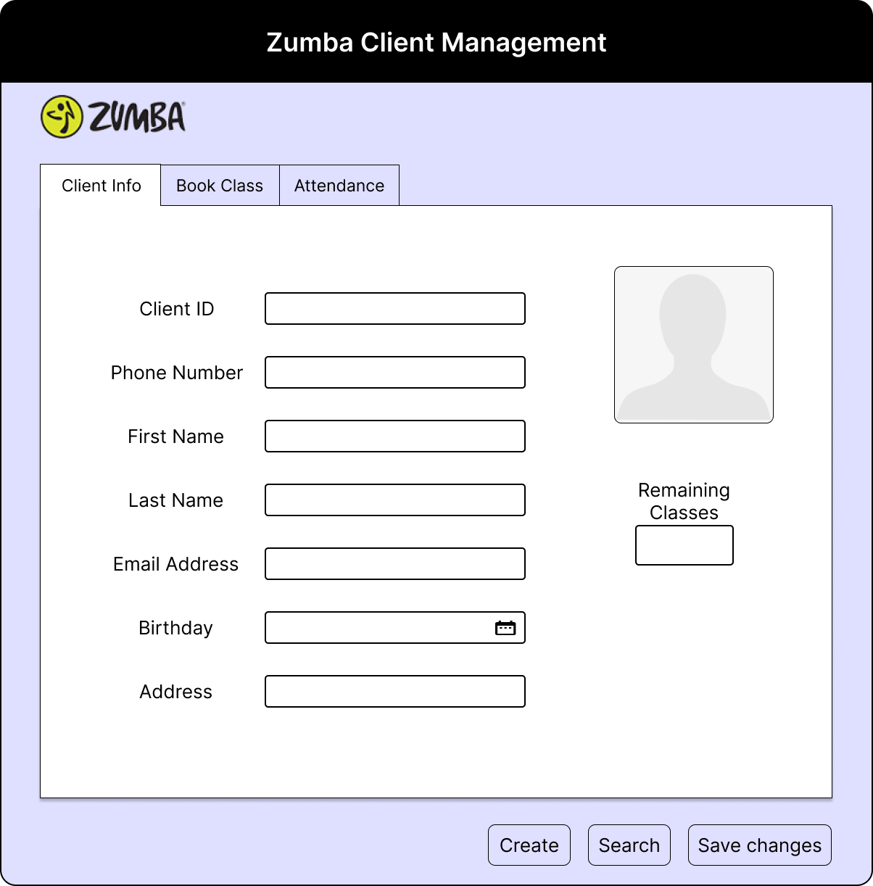

Mock-up – Class Booking

Mock-up - Attendance

